1. **VL with Quadratic: data length, regression error, non-selt match threshold, k, alpha, anomalies, time**

(0-1299),40000,100,1,1.5,(632-691),00:00:04

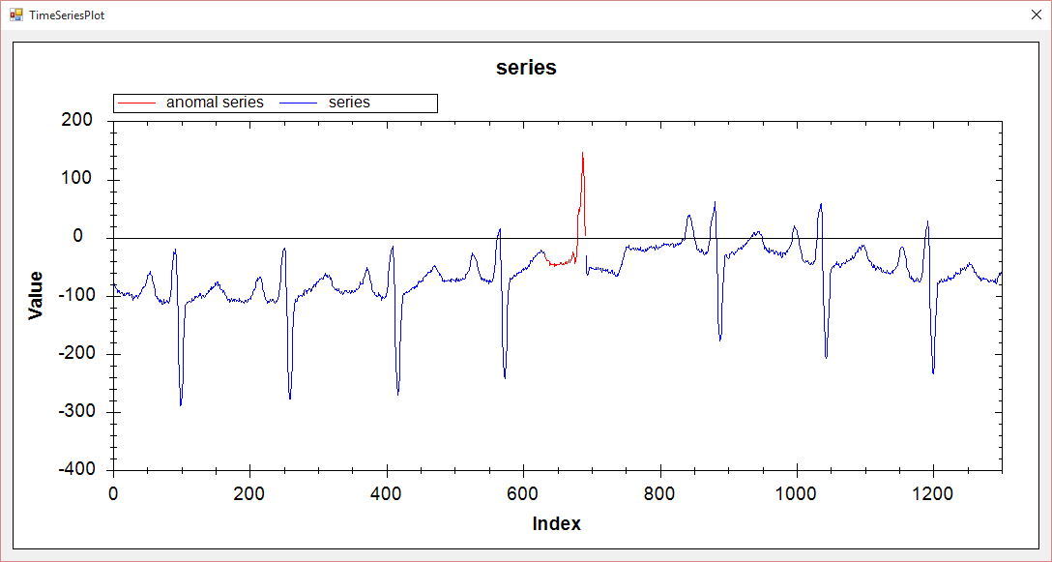

(0-1299),40000,50,1,2,(685-727),00:00:01

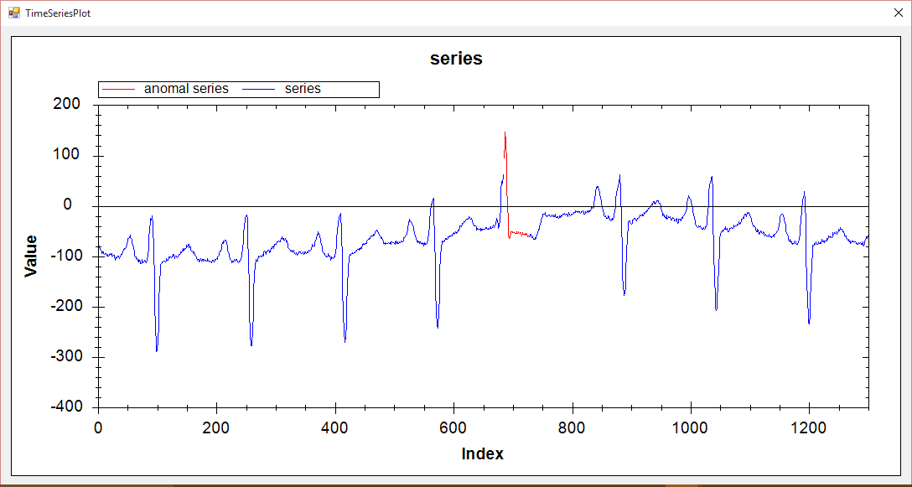

(0-1299),30000,50,1,2,(682-698),00:00:01

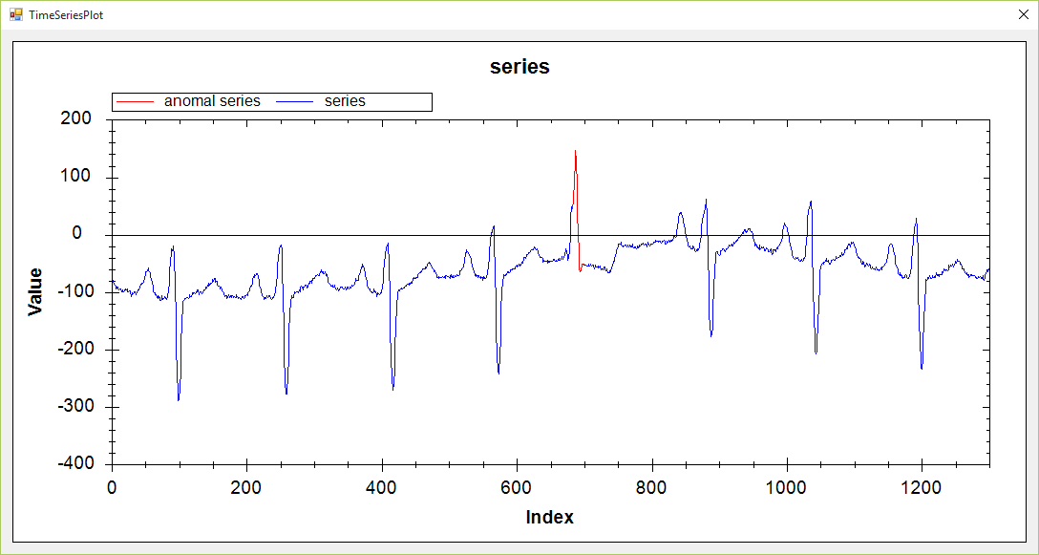

1. **VL with Extrem point: data length, ration, min length, k, alpha, anomalies, time**

(0-1299),1.05,5,1,2,(673-694),00:00:04

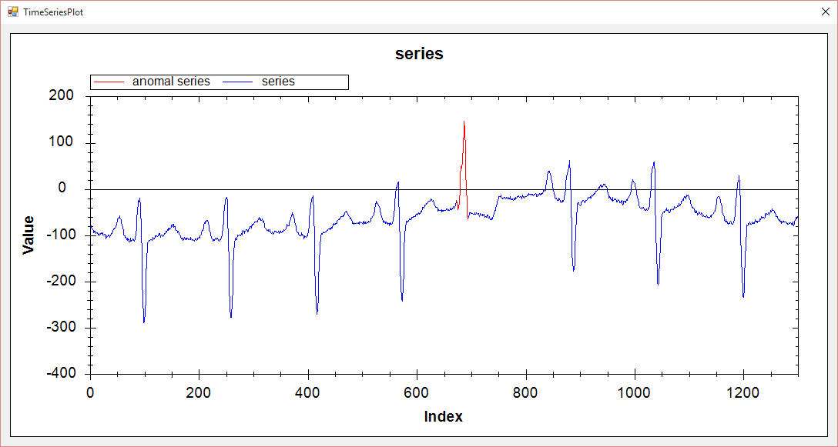

1. **Hot Sax: data length, anomaly length, paa length, discord begin, time**

(0-1299),30,3,684,00:00:10

